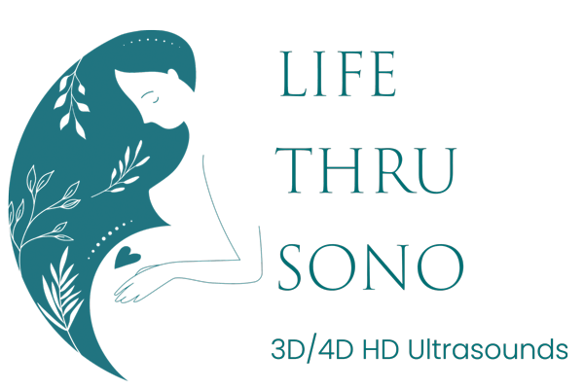

**Client Information & Waiver and Release Form**

Please complete this form online or return by email to [hello@lifethrusono.com](mailto:hello@lifethrusono.com).

NAME: ________________________________________________________________

HOME ADDRESS: ______________________________________________________

CITY, ZIP: _____________________________________________________________

PHONE: (HOME) _________________________ (WORK) _____________________

EMAIL:________________________________________________________________

DOCTOR NAME: _______________________________________________________

DOCTOR ADDRESS: ____________________________________________________

DOCTOR PHONE: _______________________________ DUE DATE: ___________

HOW DID YOU HEAR ABOUT US: _______________________________________

**Prenatal Care**: I acknowledge that I have been informed by *Life Thru Sono* that prenatal care is important to a healthy pregnancy. I am currently receiving prenatal care and my doctor has been informed and has no objections to my attending this sonography session.

**Concerns Should Be Referred to Physician:** I have also been informed by *Life Thru Sono* that use of *Life Thru Sono* services cannot substitute for care of a physician. If I have any concerns regarding my pregnancy, I will contact my doctor. I will in no way rely upon *Life Thru Sono* or its services for medical advice.

**No Professional Negligence Claims**: I am purchasing *Life Thru Sono* services and products for keepsake, non-medical purposes. I agree that I have no right to recourse against *Life Thru Sono* in any medical malpractice, professional negligence or any medical related claim arising out of or in any way related to my pregnancy or the birth of my child. This includes any claim for error in gender determination.

**Assumption of Risks**: I acknowledge that there is inherent risk in any activity involving a fetus and there are potential risks in this type of activity. I understand *Life Thru Sono* follows FDA recommendations for length of scan and frequency of ultrasound sound waves, and that no detrimental effects have been found in 40 years of studies. I hereby voluntarily assume all risk of harm or injury to me or my baby resulting from the services provided by *Life Thru Sono.*

**Waiver and Release of Claims**: I hereby waive, release, acquit and forever discharge *Life Thru Sono* from any and all claims, expenses, demands, costs, causes of action, and other actions and liabilities, of any nature whatsoever, whether known or unknown, whether in law or equity, that I or my baby may have arising out of or in any way related to my visit from *Life Thru Sono* *.* I agree that I shall have no right whatsoever to file any lawsuit or institute any other action or legal proceedings of any type arising out of or in any way related to my visit from *Life Thru Sono.*

**Photo Release:** I givepermission to *Life Thru Sono* post or use any photos or recorded data for advertisement purposes. I understand no names will be posted or used with the photos.

**Picture Quality**: I understand picture quality is dependent on many factors. I understand that *Life Thru Sono* is not always able to obtain pictures of every baby. I understand no refunds are available if unable to obtain pictures or gender.

I have notified my physician that I have chosen to obtain an elective 3-D/4-D fetal ultrasound­ from *Life Thru Sono* & I understand my physician has not ordered this. I understand that this ultrasound is not to be used to replace physician care. I have been informed that the federal Food and Drug Administration has determined that the use of medical ultrasound equipment for reasons other than medical purposes, without a physician’s prescription, is an unapproved use. I have been informed that *Life Thru Sono* follows FDA recommendations for frequency (sound waves) and length of scan which has found no detrimental effects in 40 years of case studies.

**I have read and understand all of the above. I agree to all of the above.**

**Signature: __________________________________________ Date: ______________**